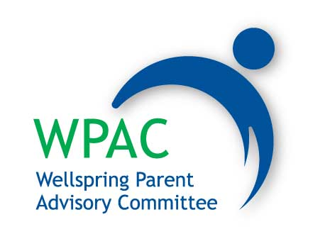

*The mission of the Wellspring Parent Advisory Committee (WPAC) is to support the school’s mission, programs and activities to the best of its ability and to act in the best interest of the entire community.*

*This mission will be carried out by striving to fulfill a variety of roles including: a) providing a forum for the exchange of ideas between parents and the school b) supporting learning for all students in line with the adopted school curriculum;  c) facilitating the development of educational activities for parents;  d) offering a variety of social support mechanisms for parents; e) promoting a positive image of the school in the larger community; and  f) organizing and promoting fundraising projects beneficial to Wellspring Learning Community as a whole.*

**Nominations and Election**

**2014-2015**